**Patroon mondmasker**

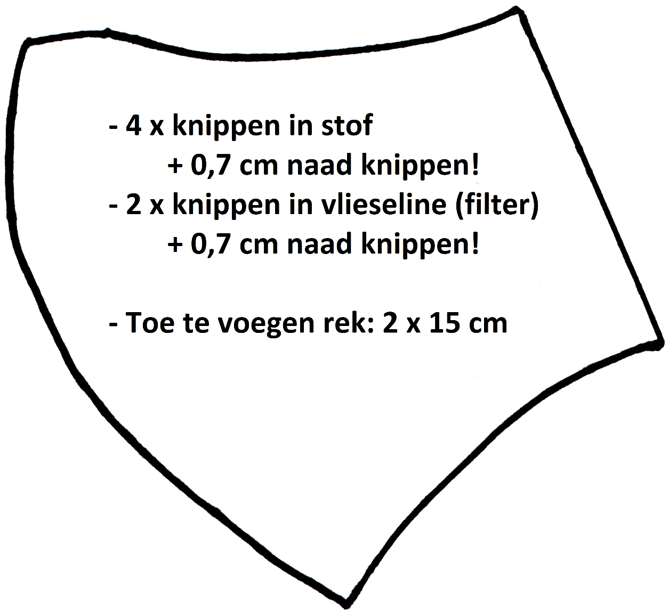

**1 x 27 cm**

**1 x 23 cm**